SIX MONTHS INDUSTRIAL TRAINING

## TRAINING REPORT

**UNDERTAKEN AT**

# “INFOWIZ”

# IN

**ADVANCED PHP**

**ON**

**“Total Event Management”**

**SUBMITTED IN PARTIAL FULFILLMENT OF THE DEGREE**

**OF**

**BACHELOR OF TECHNOLOGY**

**IN**

**INFORMATION TECHNOLOGY**



**Under the Guidance of: Submitted By:**

**Name: Name:**

**Designation: Lecturer College Roll No.:**

**Department: Information Technology University Roll No.:**

**INSTITUTE OF ENGINEERING AND TECHNOLOGY-**

**PO :, District, Punjab**

**CERTIFICATE OF TRAINING**

**Company Profile**

This project is being developed by a team of Infowiz developers and Infowiztrainees. INFOWIZ is an ISO certified US based company. It has been working from more than 5 years in the field of IT and Web Development and has been providing its clients with its exceptional and quality Web Design, Development and SEO services. Our clients range from individuals to professionals and small, medium and large scaled Businesses. In 2008, INFOWIZ entered into IT outsourcing and partnered successfully with many offshore web and SEO companies of US, UK, France, Ireland, Canada, and Australia etc. to provide them quality and timely services.

INFOWIZ does not boost itself of being the best development company but automatically enjoys reputable position among top Web Development companies because we of our timely delivery and quality work. We don’t claim for something we can’t deliver. Before taking a project from a client, we ask for all his needs and requirements. After that our skilled team of professionals analyzes the needs and comes up with a plan as how we can work to completely satisfy those requirements of our clients. We then work step by step keeping our client informed about the progress and complete the project in time giving complete contentment to them.

From concept building to implementation of any project, our team manages the projects efficiently up to its completion. Our tactful strategy and dedication towards quality work has given us the recognition we enjoy and that is why our clients only come back to us whenever they require any kind of web related solutions. We do not only emphasize on formulating an attractive solution to our clients, but we believe in providing a workable solution. INFOWIZ is an organization which is established in the field of VLSI-VHDL, Embedded systems, PHP, .NET, Web Designing, Web Development, Network Support and Network training.

**Acknowledgement**

.

**Index**

|  |  |  |  |
| --- | --- | --- | --- |
| Sr. No | Topic |  | Remarks |
| 1. | Introduction |  |  |
| 2. | About The Project |  |  |
| 3. | Problem Statement |  |  |
| 4. | Importance of Computerization |  |  |
| 5. | Need for Changing The existing System |  |  |
| 6. | Objective |  |  |
| 7. | Requirement Analysis |  |  |
| 8. | Data Flow Diagram |  |  |
| 9. | Projective Objective |  |  |
| 10. | Software requirement Specification |  |  |
| 11. | Performance Requirement |  |  |
| 12. | Introduction To PHP |  |  |
| 13. | Screenshots |  |  |
| 14. | Bibliography |  |  |
|  |  |  |  |

***Introduction***

The idea of Total Event Management was conceived during one of our brainstorming sessions, when one of our counterpart pointed out the many constraints for find services required for organizing an event and the non-availability of a platform which housed all required services under one name.

Thus, the idea ‘Total Event Management’ was born!

With our site, we strive to achieve the best services at competitive prices. Our user-friendly site houses the most important services required for organizing an event; all under one banner. This site was developed in order to help reduce the time and energy wastage of an average customer on locating services and instead enjoying the joys of an occasion.

***ABOUT THE PROJECT***

Event System is an online system which helps the event to be managed. It has three ends:

* Vendor end
* Administrator end
* User end

A vendor can create his account on his site and book the order according to their schedule. He can see all the order that are available for the booking and book an order. ADMIN end can manage the entire site. He can see all the orders booked by the client and can view which services are booked by the vendors and which services are pending for booking.

**PROBLEM STATEMENT**

The problem arose when one wanted to organize an event. The amount of time that was wasted in finding all services required robbed the customer of enjoying the joys of an occasion. Since, there was a non-availability of a user-friendly platform that not only housed a variety of services but also at the most competitive rates. The customer first needed to contact or visit a large number of brokers and tell them the details of the event they were organizing; same if someone he also contacts brokers and tell them specifications of their needs Tthe brokers then acts as an intermediate and makes the work done by charging an obscene amount for the services provided.

Another is that customer whether wants to organize an event like birthday, marriage etc visit the site to see the various services which is quite a cumbersome task. Through this project we have tried to make the process less time consuming and affordable for all. This was done by managing the event services while sitting at their own places and getting the contacts of the brokers through one site and one can upload or see the site images on the website.

**IMPORTANCE OF COMPUTERIZATION**

Event Management System is concerned with finding all required services for organizing a successful event. This would help a user to locate services, book services in order to reduce the wastage of time and energy and instead enjoying an occasion.

* Viewing all services
* Booking a service
* Confirming orders
* Locating all required services for organizing an event.

**Need for a change from the existing system**

In the field of information technology, it is need of honor to have a fast information processing system capable of providing the processed data at right time to a right person which appropriately justifies by the following limitation of the manual system:-

* Delay in information search and retrieval.
* Problem in updating of current information and maintaining proper backup of information.
* Possible damage of the paper carrying the information, thereby chances of loosing valuable information.
* Much time required in providing correct information.
* Secrecy of information may not be maintained due to visible facts on paper.
* Less reliability and maintainability of data.

From the description of the present system and problems with the existing system, one can gauge the manpower wasted in these activities, even then it’s difficult to gain access to different information. Addition, updating, viewing searching and deletion are very easy in the computerized system. Just by clicking on the figures, different information can be accessed. So, here lies the need for a change from the old age system to a new updated system.

***Objective***

**Objectives of new system**

The system must perform following function:-

* To provide on all services provided for oraganizing an event.
* Allow administrators to add details to index to provide accurately.
* To save the precious time of administration.
* To save the precious time of users by giving customized web site.

**“The objective of our system is to create a user-friendly system which will be more efficient, save time and be easy to use.”**

### Features :

* Provide all services needed for organizing an event under one banner
* Provide competitive prices for services provided.
* User-friendly approach enables user to spend less time on locating and booking services.
* Add new and exciting services.

#### Clients :

* Client can book the order as per their requirements.
* View all services
* Make changes in the account

#### Administrator:

* View all services.
* View all users
* View all vendors
* View all booked orders
* Make changes in entire site.

**Vendor:**

* View all booked services
* Confirm all orders
* Make changes in account.

***Requirement Analysis***

The project will have the following requirements:-

Hardware requirements:-

|  |  |  |
| --- | --- | --- |
| Requirement | Minimum | Best |
| Processor | Intel Pentium 4.2.24 | Any higher processor than Intel Pentium 4.2.24 |
| Motherboard | 845GL/GV | 845GL/GV |
| RAM | 128 MB | 128 MB - 4 GB |
| HDD | 20 GB | 500 GB |
| Wamp server | 2.1 | 2.3 |
| Display | Color Monitor(VGA) | Color AGP(4MB/8MB) |

Software requirements:-

* **Environment:** Win XP/ Win 98/ Win 2000/ Win 2003/ Win Vista/ Win 7.
* **Platform:** PHP as Front -end. My SQL as Front -end
* **Duration:** 6th months training priod.

Tools/Environment Used:-

* **Platform/Environment Used:** Microsoft Windows 7.

Hardware Interface:-

The forms are used with links and command buttons. Normalized tables are prepared. The present project uses query-based programs to summarize the resultants. Also message boxes are used to guide user at every instant. Search engine is also use to find the particular record.

Software Interfaces:-

* Windows 7 as Operating System.
* Php as Front-end.
* My SQL as Back –end.

***Software Requirement Specification***

**Feasibility Study**

A feasibility study looks at the viability of an idea with an emphasis on identifying potential problems and attempts to answer one main question: Will the idea work and should you proceed with it?

Before you begin writing your business plan you need to identify how, where, and to whom you intend to sell a service or product. You also need to assess your competition and figure out how much money you need to start your business and keep it running until it is established.

Feasibility studies address things like where and how the business will operate. They provide in-depth details about the business to determine if and how it can succeed, and serve as a valuable tool for developing a winning business plan.

Why Are Feasibility Studies so Important?

The information you gather and present in your feasibility study will help you:

* List in detail all the things you need to make the business work;
* Identify logistical and other business-related problems and solutions;
* Develop marketing strategies to convince a bank or investor that your business is worth considering as an investment; and
* Serve as a solid foundation for developing your business plan.

Even if you have a great business idea you still have to find a cost-effective way to market and sell your products and services. This is especially important for store-front retail businesses where location could make or break your business. For example, most commercial space leases place restrictions on businesses that can have a dramatic impact on income. A lease may limit business hours/days, parking spaces, restrict the product or service you can offer, and in some cases, even limit the number of customers a business can receive each day.

The Components of a Feasibility Study:

Description of the Business: The product or services to be offered and how they will be delivered.

* [**Market Feasibility:**](http://womeninbusiness.about.com/od/freebusinesscourses/a/marketdeasibil.htm) Includes a description of the industry, current market, anticipated future market potential, competition, sales projections, potential buyers, etc.
* [**Technical Feasibility:**](http://womeninbusiness.about.com/od/startingasmallbusiness/a/techfeasibility.htm) Details how you will deliver a product or service (i.e., materials, labor, transportation, where your business will be located, technology needed, etc.).
* [**Financial Feasibility:**](http://womeninbusiness.about.com/od/freebusinesscourses/a/finfeasibility.htm) Projects how much start-up capital is needed, sources of capital, returns on investment, etc.
* [**Organizational Feasibility:**](http://womeninbusiness.about.com/od/freebusinesscourses/a/organizatfeas.htm) Defines the legal and corporate structure of the business (may also include professional background information about the founders and what skills they can contribute to the business).
* [**Conclusions:**](http://womeninbusiness.about.com/od/freebusinesscourses/a/conclusionsfeas.htm) Discusses how the business can succeed. Be honest in your assessment because investors won’t just look at your conclusions they will also look at the data and will question your conclusions if they are unrealistic.

Three key feasibility considerations involved in the feasibility are:

**Economic Feasibility**

Economic analysis is the most frequently used method for evaluating the effectiveness of a new system. More commonly known as [cost/benefit analysis](http://en.wikipedia.org/wiki/Cost-benefit_analysis), the procedure is to determine the benefits and savings that are expected from a candidate system and compare them with costs. If benefits outweigh costs, then the decision is made to design and implement the system. An entrepreneur must accurately weigh the cost versus benefits before taking an action.

* **Cost-based study:** It is important to identify cost and benefit factors, which can be categorized as follows: 1. Development costs; and 2. Operating costs. This is an analysis of the costs to be incurred in the system and the benefits derivable out of the system.
* **Time-based study:** This is an analysis of the time required to achieve a return on investments. The future value of a project is also a factor.

Various economic benefits can be given as:

* Increase in the rate of processing of applications.
* Reduction in the number employees employed.
* Low maintenance cost.
* Low loss of human working hours.
* Accounts can be managed.

**Technical Feasibility**

Technical feasibility enters on the existing computer system and to what extent it can support the proposed system. The system developed by us is technically feasible since it is user friendly and is capable of fulfilling their requirements about the costing process of the products.

Various considerations for the technical feasibility:

* Streamlining of the records into a single system.
* Usefulness in planning proposes.
* Easy accessibility of the records.
* Inter connection of the various nodes.
* Comprehensive and foolproof independence.
* Easy to operate and maintain in long run.
* Can be easily enhanced in the future.

**Social Feasibility**

It is important to study the social implication when a new product or system is introduced. People are inherently resistant to change and computers have been known to facilitate change. An estimate should be made of how strong a reaction user staff is likely to have towards the development of a computerized system. It is common that computer installation results in turnover, transfers, retraining and changes in the employee’s job status. Therefore, it is undesirable that the introduction of the candidate system requires special effect to educate, sell, and train the staff on new ways of conducting business. When we explained our system to users, they gave a good response.

**Analysis Phase**

Analysis is a detailed study of various operations performed by a system and their relationship within the system and outside the system. A key question is that what must be done to solve a problem? One aspect of analysis is defining the boundaries of the system and determining whether or not a candidate system should consider other related systems.

The tools that are used in the analysis of a given system are data flow diagrams, interviews, on-site observations, questionnaires sessions. Out of theses interviews and on-site observations are quite useful and are most frequently used tools for collecting information.

Techniques used in information gathering:

For designing a new system we need to get information about the existing system. This helps to determine the shortcomings of the existing system. There are various information-gathering tools available which provide a great deal of help in obtaining information about the existing system and about the requirements of new system.

The tools used by us in gathering information about the working at the are:-

* On-site observation
* Review of written documents
* Questionnaires

***Performance Requirements***

* **Speed**

The system developed is more efficient since the connection is made through RDO faster access to data is made possible. The system developed was used by nearly 10 to 12 potential users at a time and consistency is maintained to the maximum.

* **Attributes**
  + Flexibility

The system is flexible enough to adapt to changing technology as well as change in business and user requirement.

* + Reliability

The system provides a high degree of resilience and overall reliability. The system incorporates redundancy in critical components and ensures that there is no single point of failures.

* + Security

The system provides the necessary features to ensure that the access of information is protected based on the user.

* + Easier to use

Navigating around your computer is easier than errors, thanks to develop options such as single clicking to open files and addition of browse buttons in every window. You can now use multiple monitors with a single dramatically increasing the size of your workspace.

* + Faster

Windows and programs open faster than before. By, using the maintenance wizard, you can easily improve your computer’s speed and efficiency. The power management feature allows newer computer’s to go hibernation mode and awaken stately, file.

**FRONT END**

**PHP**

PHP is a server-side, cross-platform, HTML-embedded scripting language. Currently there are over half a million domains running PHP and it is freely available for download online from [www.php.net](http://www.php.net). Much of PHP’s syntax is borrowed from C, Java and Perl with a couple of unique PHP-specific features thrown in. The goal of the language is to allow web developers to write dynamically generated pages quickly. PHP eliminates the need for numerous small cgi programs by allowing you to place simple scripts directly in your HTML files. It also makes it easier to manage large web sites by placing all components of a web page in a single html file.

For example, if you are creating an online catalog, you will most likely have a design template for all related catalog pages. Traditionally, this design is generated by hand in HTML and different data is presented within the template design. With PHP, one application can be used to generate all the pages required to display items from a database in the proper pages, in the right locations, and with the appropriate related content. This eliminates redundant page generation, simplifying maintenance. PHP also reduces the site down to a handful of template pages, with scripts that generate the rest of the site.

PHP is an excellent alternative to such similar programming solutions as Microsoft's proprietary scripting engine ASP and Allaire's rather expensive ColdFusion. As mentioned before, PHP is a cross-platform language. This doesn't stop with the core PHP code but can be extended to all of PHP's libraries and all code written in PHP. Neither ASP nor ColdFusion can make this claim. PHP has a large feature set which includes built-in support for numerous databases (including Access, LDAP, Oracle, and MSSQL), networking support, zip archiving ,and an excellent set of built-in functions. Furthermore, due in part to it being open source and freely available for download on the web, the language enjoys an active developing environment. Since the syntax structure borrows heavily from C, it is easy for even the novice programmer to learn the language. PHP is also the oldest HTML-embeded scripting language, giving it a head start on all the others.

If you are a content developer, you probably won’t want to learn PHP scripting by heart. But, it is nice to know how PHP can help you create more powerful web applications and user-friendly designs.

### How PHP Works…

When you create a PHP application, you create PHP script files which are plain text files comprising a combination of standard HTML code and script commands. While web servers normally send HTML files directly to the client’s web browser in response to HTTP (HyperText Transfer Protocol) requests, the web server first processes the content of PHP scripts before sending output to clients. Within a PHP script, standard HTML code is sent directly to the browser, while script commands are executed locally on the web server. The script output can then be sent to the browser as standard HTML.

|  |
| --- |
| <HTML>  <HEAD><TITLE>My First PHP Script</TITLE></HEAD>  <BODY>  <? echo("Hello World!<P>"); ?>  </BODY>  </HTML>[[[ Run Script ]](http://www.webguys.com/pdavis/Programs/What_Is_PHP/First.php3)](http://www.webguys.com/pdavis/Programs/What_Is_PHP/First.php3) |

Note the two <?...?> tags in the above text. This syntax indicates PHP commands that are interpreted by the server instead of being passed to the client. You may jump in and out of PHP mode in an HTML file like this all you want. This program is extremely simple and you really didn't need to use PHP to create a page like this. All it does is display "Hello World" using the ECHO command. With ECHO you can print out strings enclosed in quotes, variables, or a combination of both. At the end of the ECHO command you will see a semicolon (;). Almost every PHP command must end in a semicolon (;).

By clicking on the blue magnifying glass in the bottom right corner of the code window above you can view the code results in a separate browser window. If you view the source, you will see the following:

|  |
| --- |
| <HTML>  <HEAD><TITLE>My First PHP</TITLE></HEAD>  <BODY>  Hello World!  </BODY>  </HTML> |

As you see, the scripting commands are not visible on the client side. This is good because it keeps the source code for the PHP protected. This means the original PHP code cannot be downloaded and copied without permission. So let's try something useful by generating a table of font colors generated on the fly. If you were to do this by hand it would take a very long time, with PHP it only takes a very few well placed lines of code.

|  |
| --- |
| <HTML>  <HEAD><TITLE>PHP Font Chart</TITLE></HEAD>  <BODY>  <TABLE>  <?  for($iR = 0; $iR <= 255; $iR += 51) {  for($iG = 0; $iG <= 255; $iG += 51) {  ?>  <TR>  <? for($iB = 0; $iB <= 255; $iB += 51) { ?>  <TD>  <FONT COLOR="<? printf("%02X%02X%02X", $iR, $iG, $iB); ?>">  Font #<? printf("%02X%02X%02X", $iR, $iG, $iB); ?>  </FONT>  </TD>  <? } ?>  </TR>  <? } } ?>  </TABLE>  </BODY>  </HTML> |

***BACK END***

***MY SQL***

**SQL SERVER**

SQL Server is an SQL-compliant RDBMS. SQL-compliant means it use the ANSI (American National Standard Institute) version of Structured Query Language or ‘SQL’. Structured Query Language is a command that allow us to modify or retrieve information from the database.

Client server means that SQL Server is designed to store data in the central location (the server) and deliver it on demand to numerous other locations (the client). SQL Server is also a Relational Database Management System (RDBMS).

**Features of SQL Server**

* Information representation
* Unique definition of rows
* Systematic treatment of Null values
* Guaranteed access
* High level Update, Insert, and Delete
* Retrieving information from the database.
* Accepting query language statements.
* Enforcing security specifications.
* Enforcing data integrity specification
* Enforcing transaction consistency
* Managing data sharing
* Optimizing queries
* Managing System catalogs

**Enterprise Manager**

SQL Server Enterprise Manager is a graphical tool that allows easy configuration and management of Microsoft SQL Server and SQL program group.

SQL Server Enterprise Manager can also be used to:

1. Manage logins, permission and users.

2. Create a database

3. Take back-up of database and transaction logs.

4. Manage tables

**Query Analyzer**

The SQL Server Query Analyzer allows us to create adhoc queries and run them interactively. We may also execute Transact-SQL statements stored in text file and view the result in result plane or result grid. The Query Analyzer also has a color-coded editor to assist the user with checking of syntax. It also has context sensitive help. Queries are processed in two steps:

* **Interpret-** First the Queries are checked for syntax.
* **Execute***-*Then the processing take place.

***DATA FLOW DIAGRAM***

DFD for admin :

*DFD for Client*

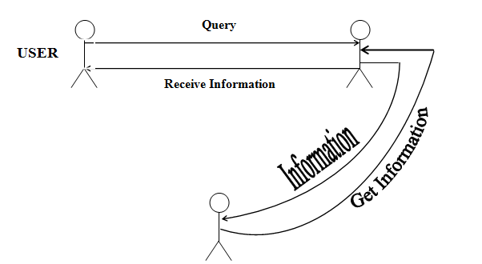

***SCREENSHOTS***

Home page:

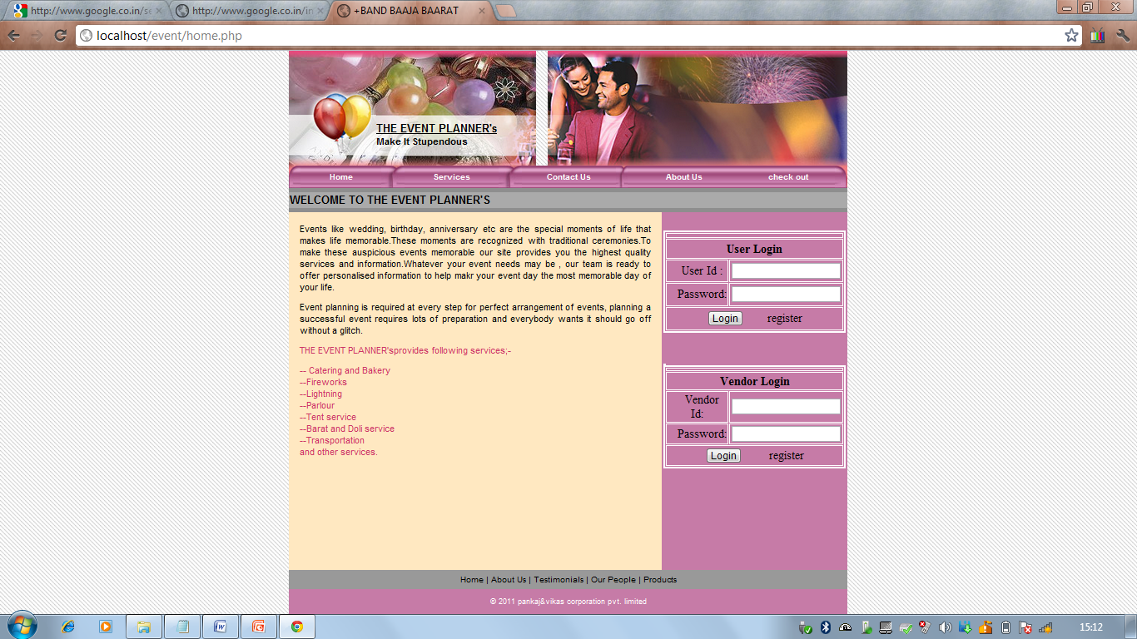

Services:-

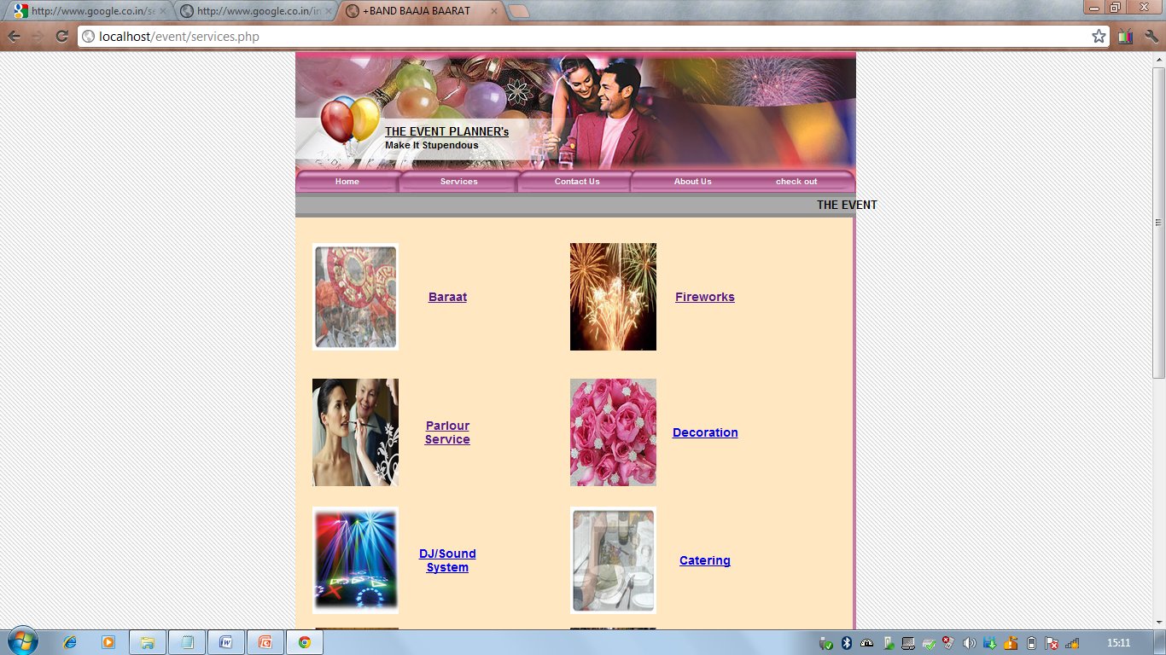

Baraat Service:-

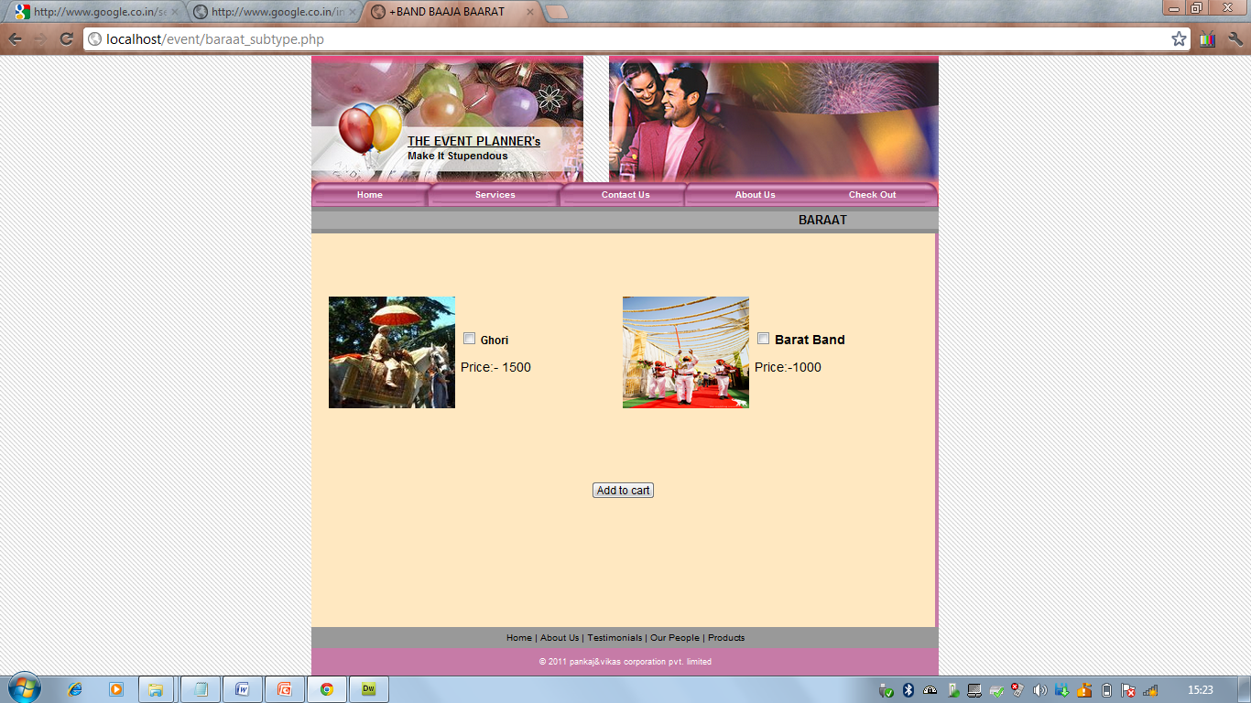

Decoration:-

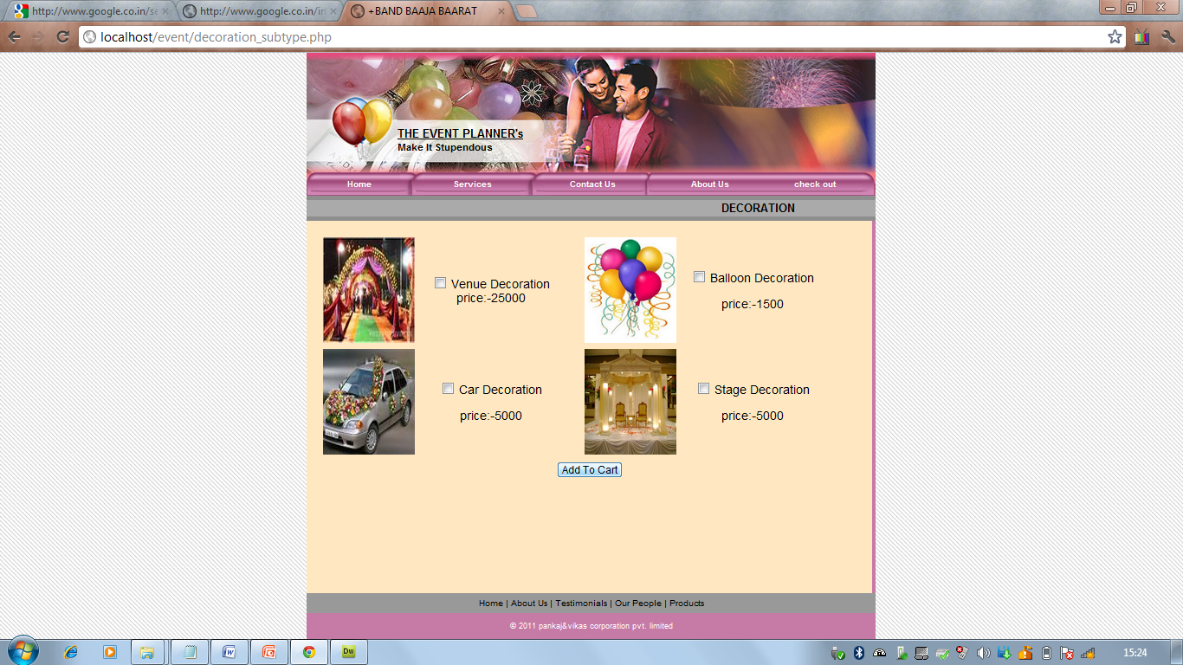

Sound System:-

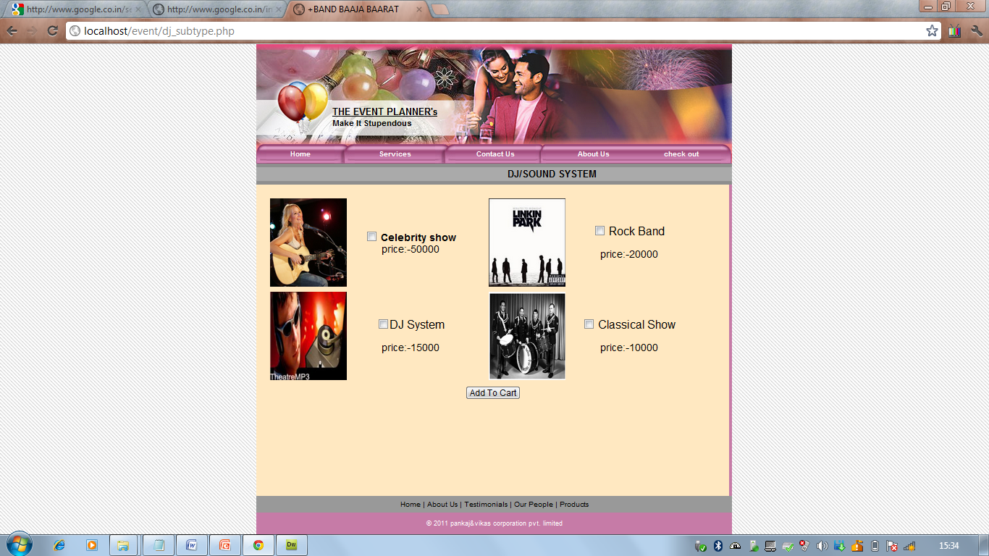

Catering:-

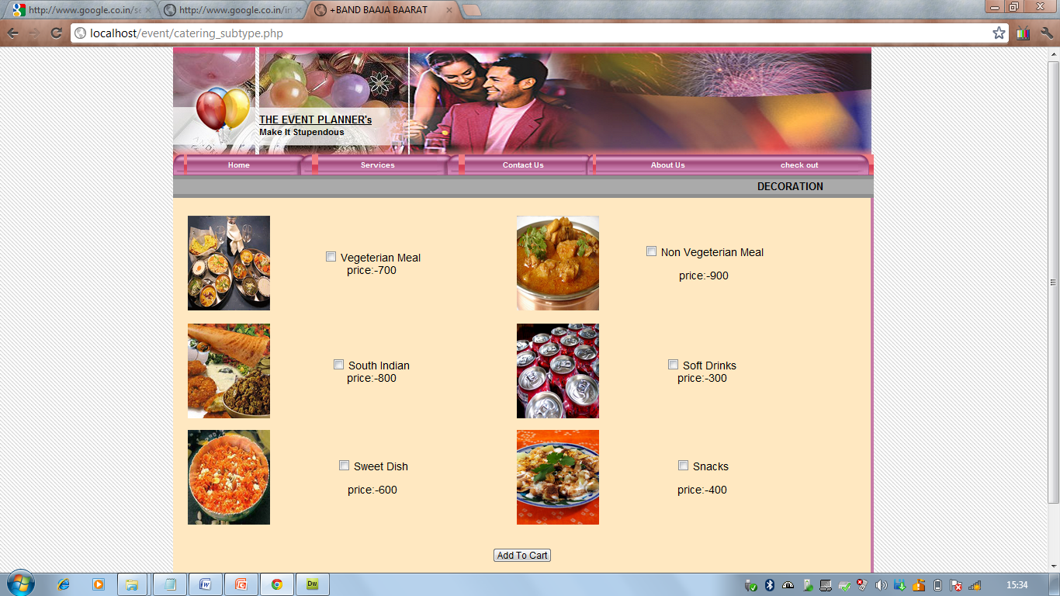

Transport:-

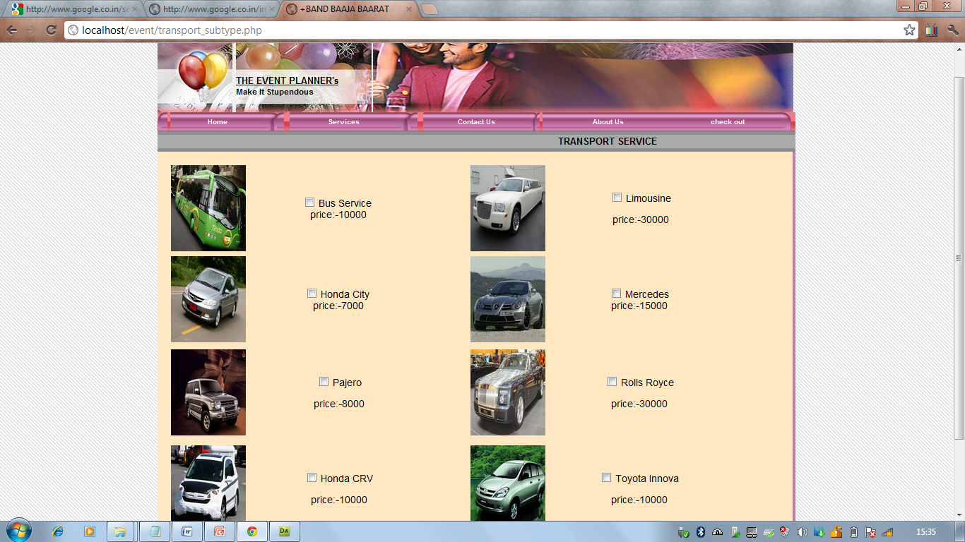

Card Design:-

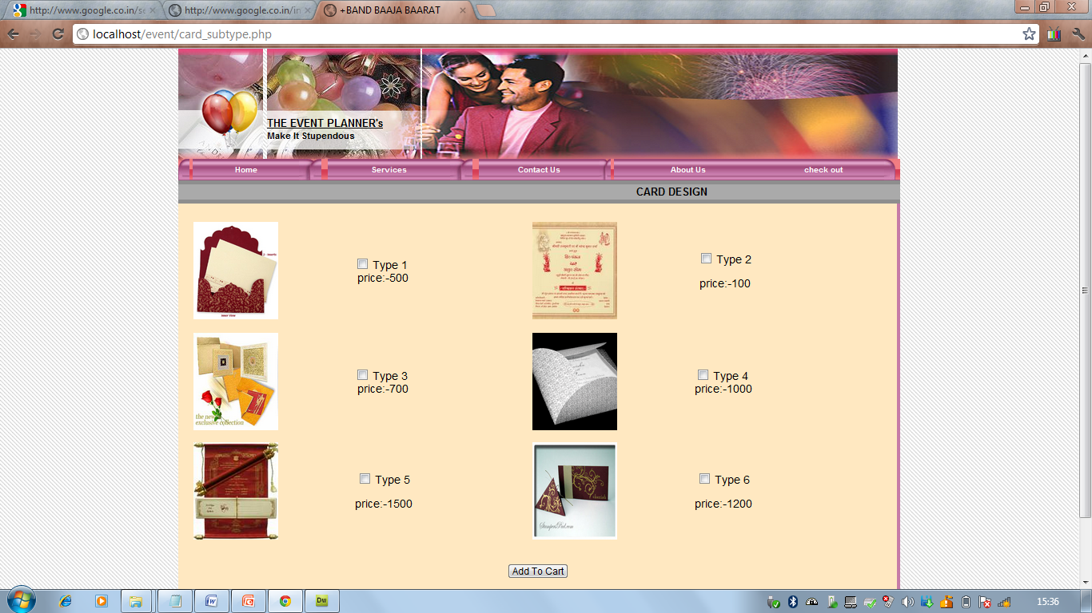

Tent Service:-

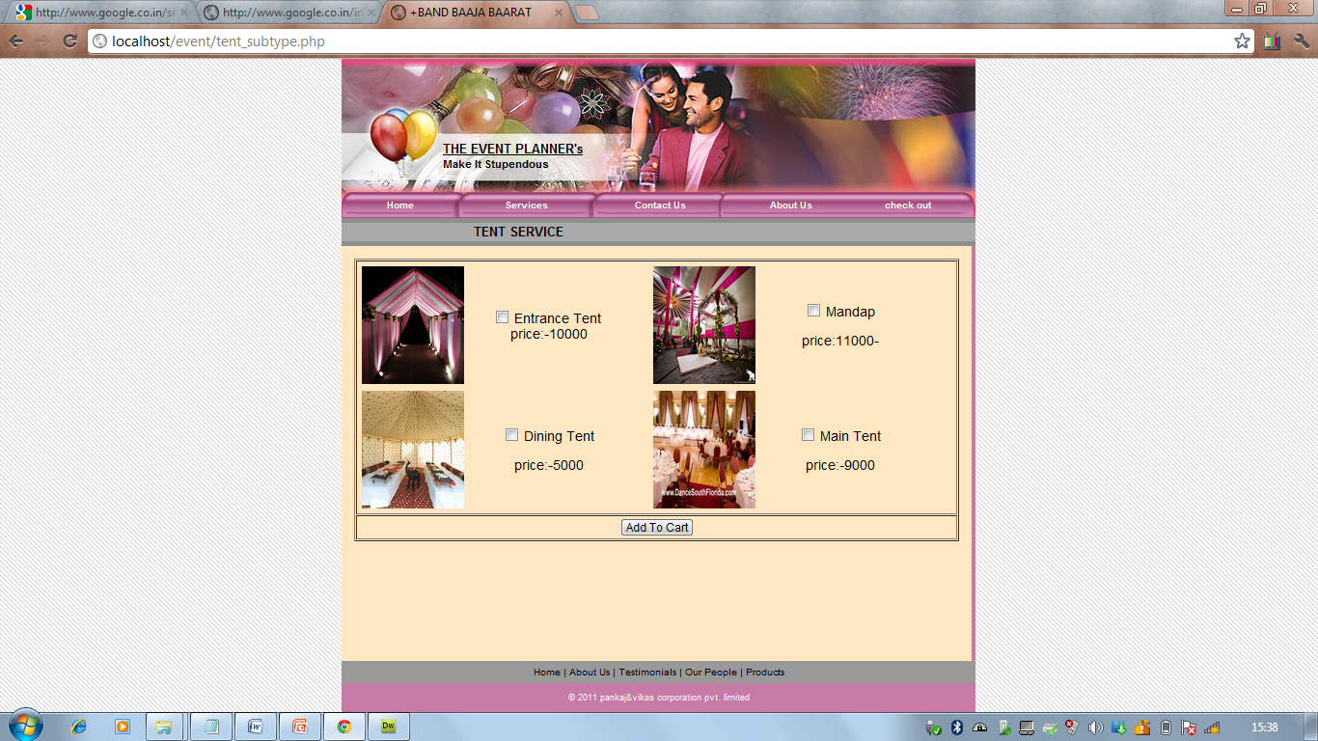

Doli Service:-

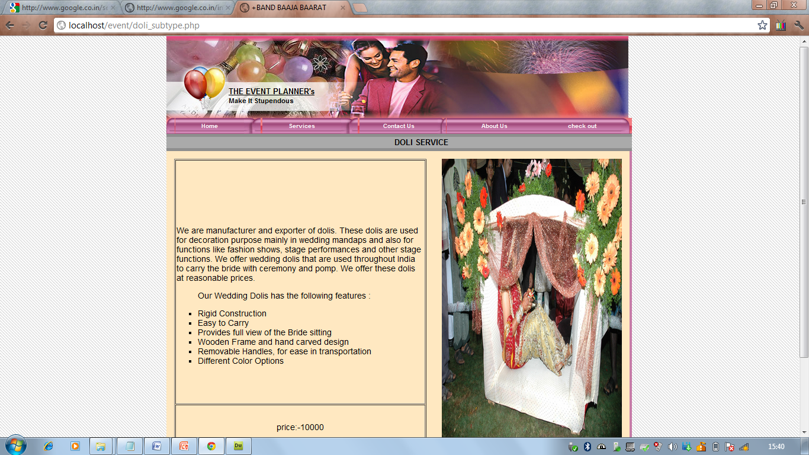

Vendor Registration:-

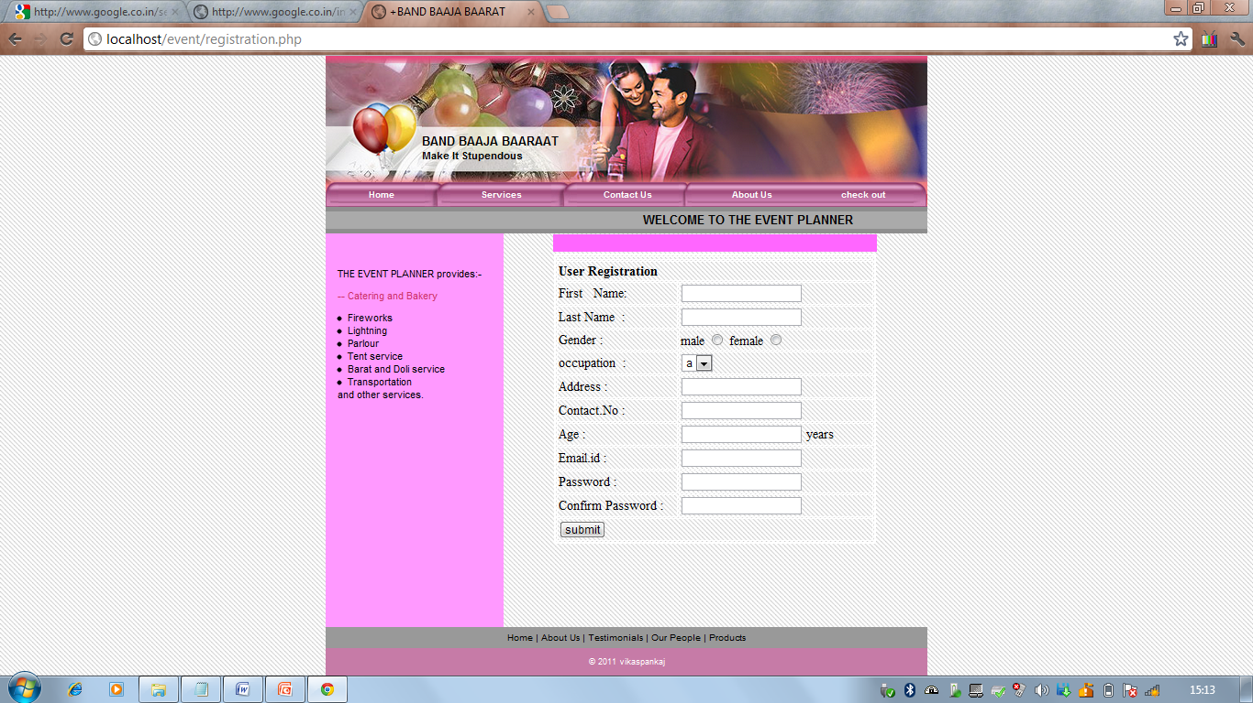

Vendor Page:-

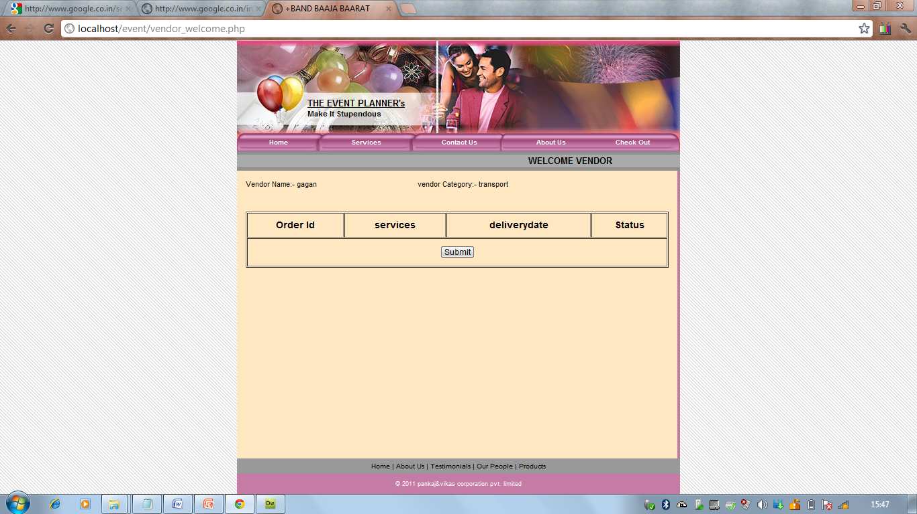

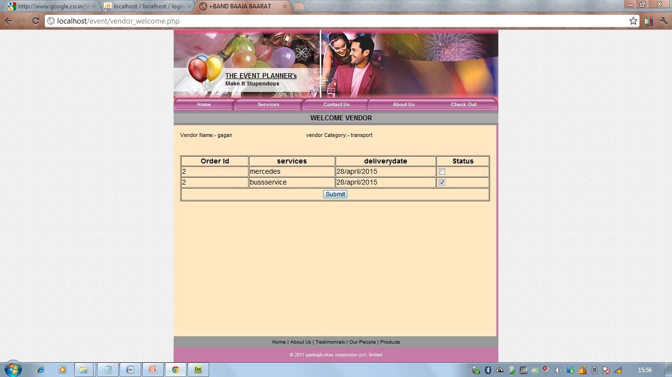

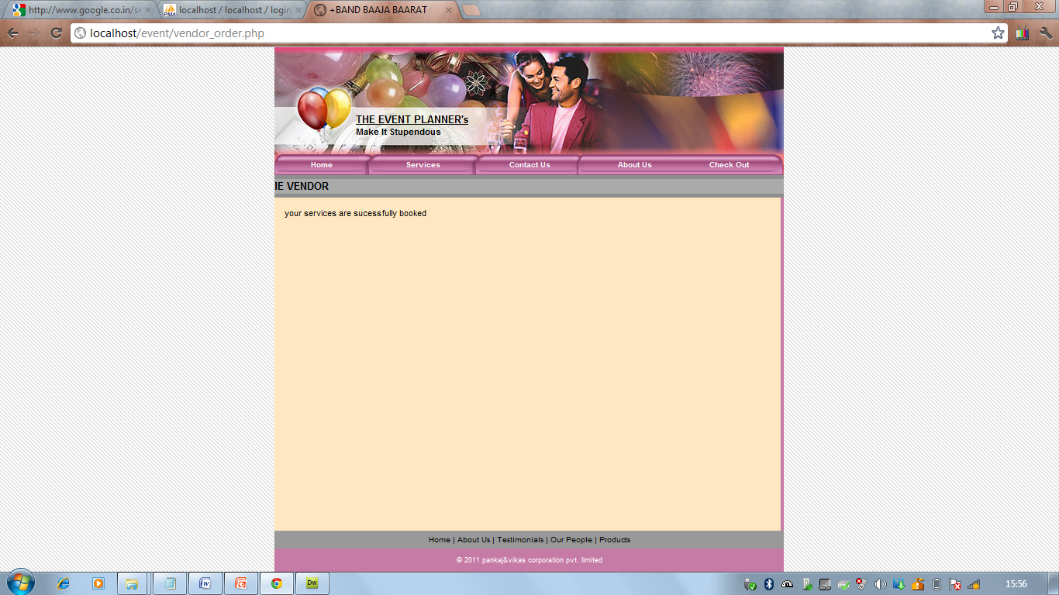

Admin:-

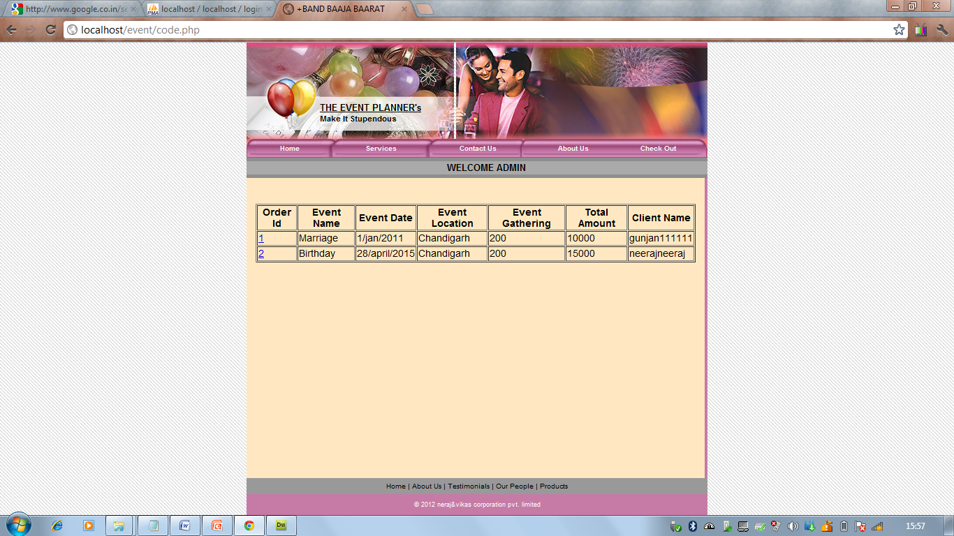

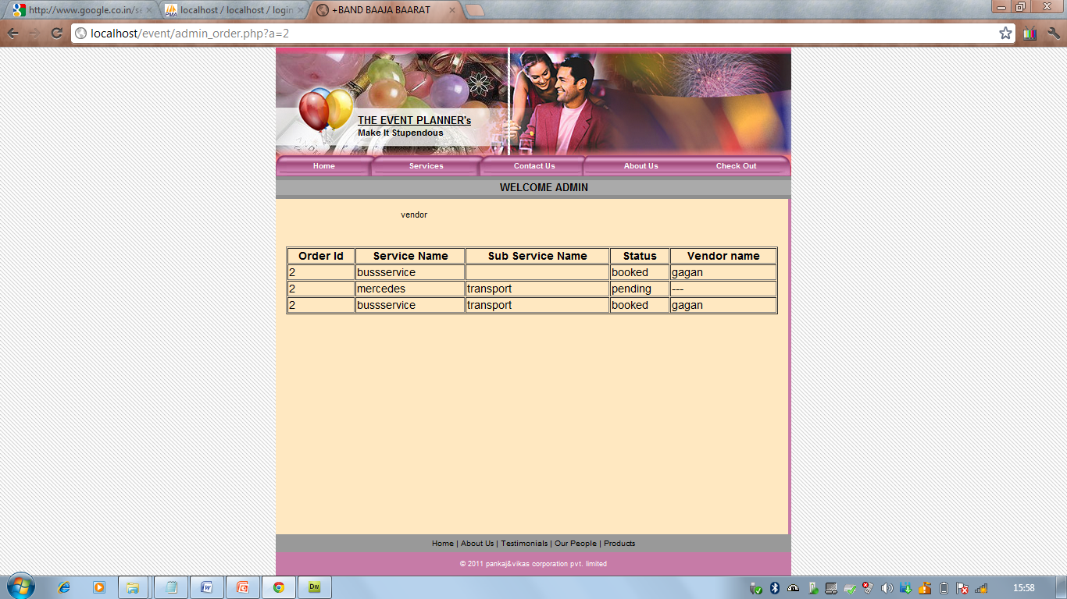

User Registration:-

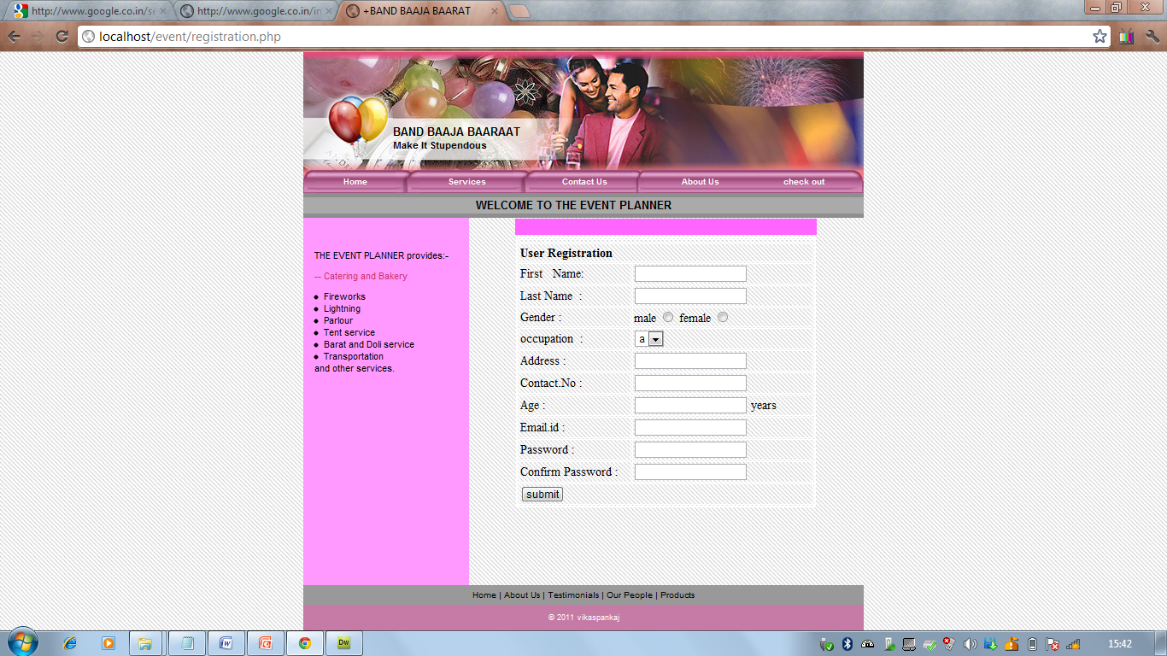

Order Detail:-

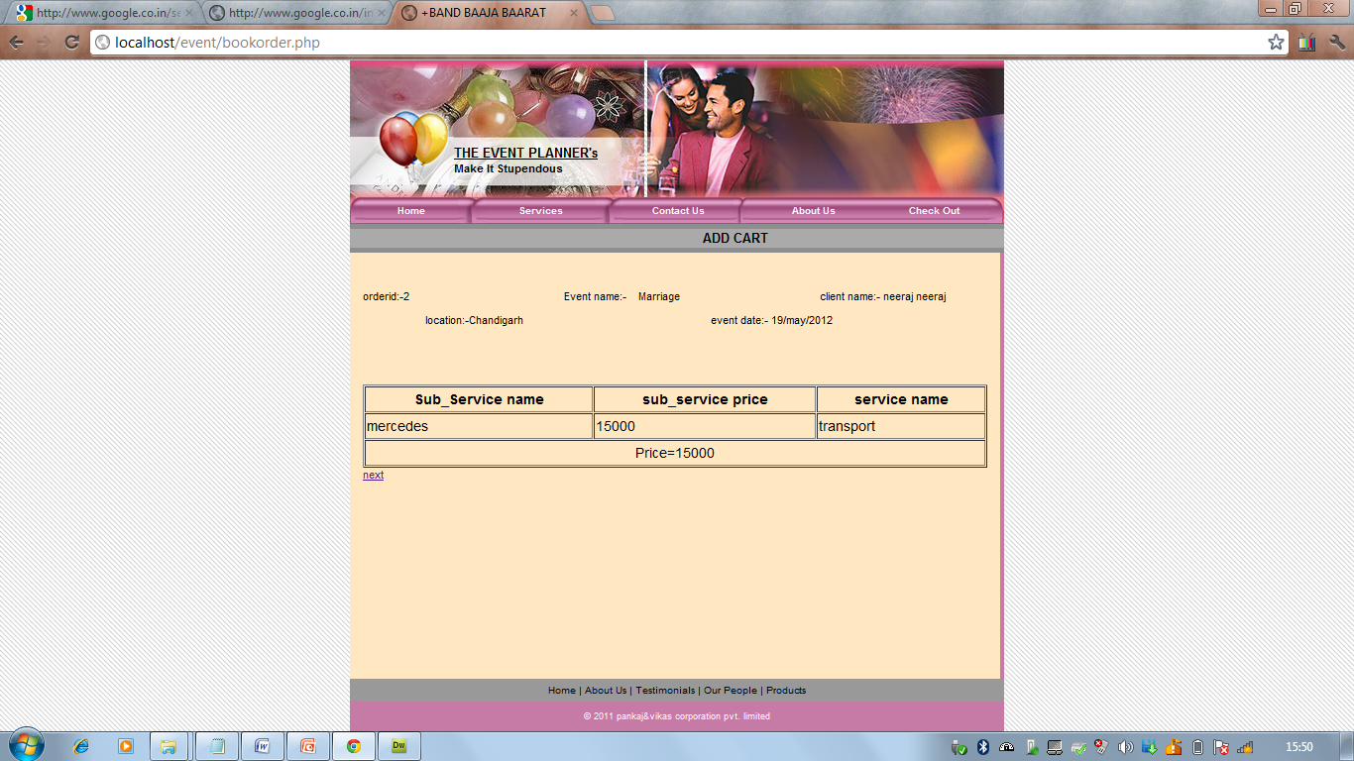

Contact Us:-

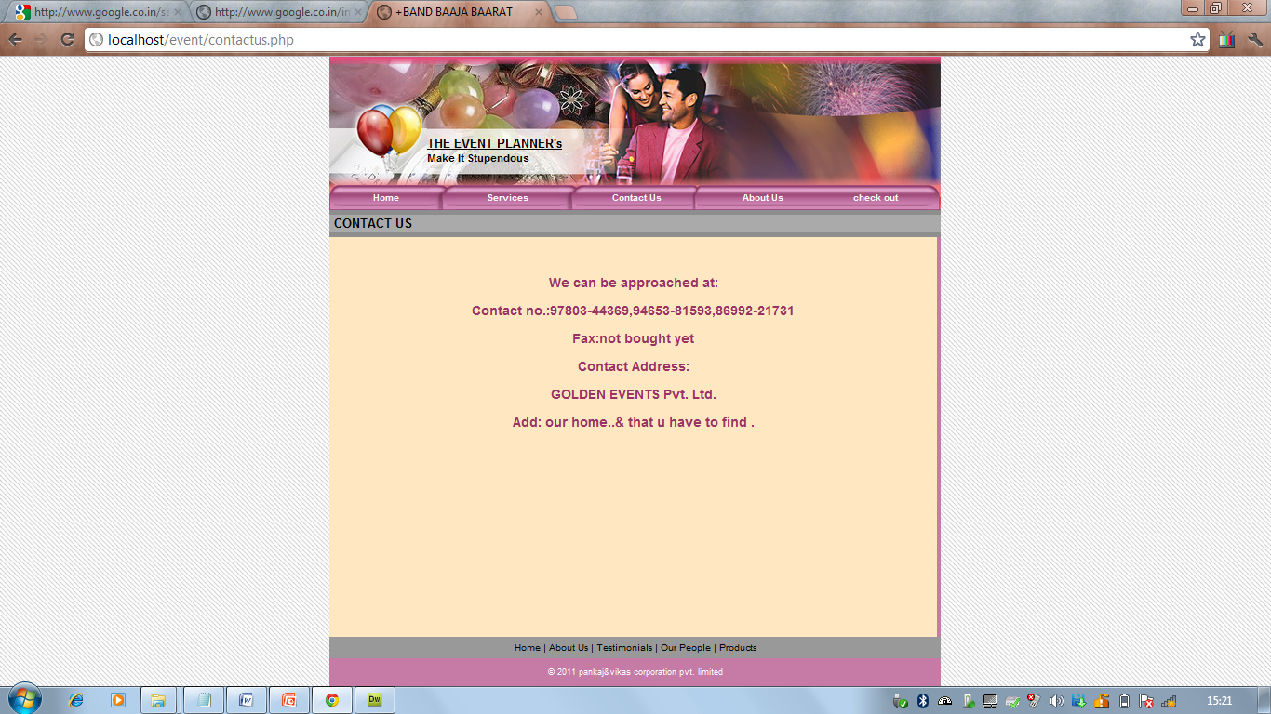

Request Confirmed:-

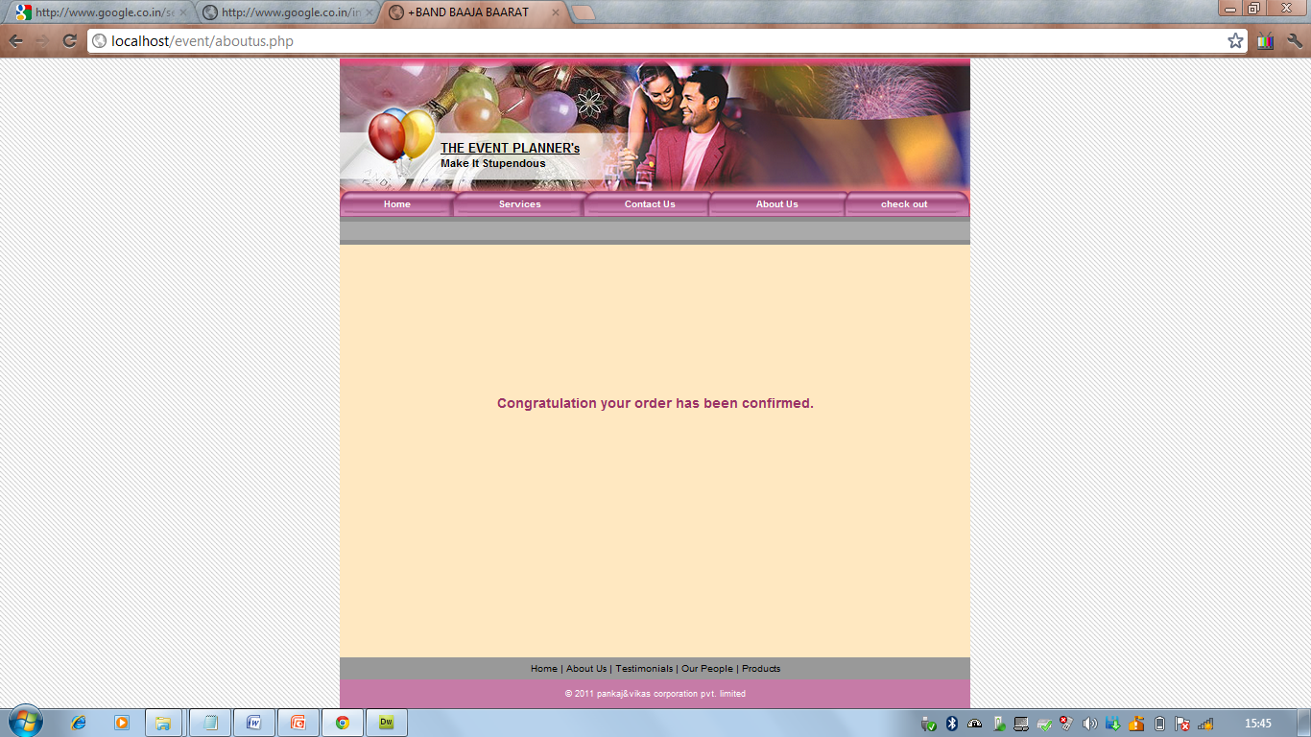

***BIBLIOGRAPHY***

<http://www.google.com>

<http://www.php.net>

<http://www.w3schools.com>

***BIBLIOGRAPHY***